Cambodian Independence Day

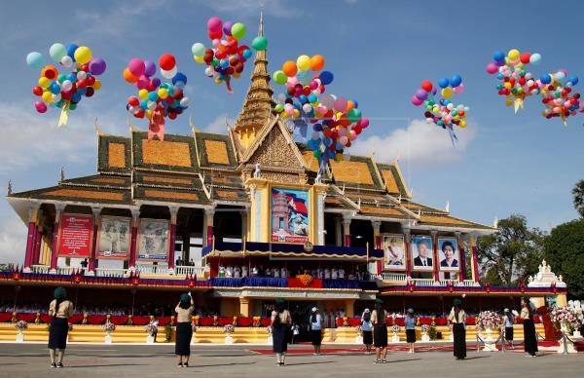

Independence Day (Khmer: បុណ្យឯករាជ្យជាតិ) is a national holiday observed annually in Cambodia every 9 November. The date celebrates Cambodia's Declaration of Independence from France on 9 November 1953.

The site to celebrate the ceremony is at Independence Monument. The vital celebrations are held in the capital city, Phnom Penh although there are some celebrations in many provinces.

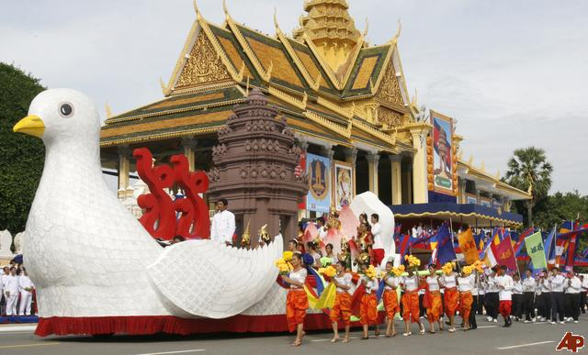

This day’s celebration marks the independence of Cambodia from 90 years of French rule. It is celebrated at the Independence Monument and the event is presided by the ruling king of Cambodia, with Cambodians from different professions coming together every year to rejoice over their independence.

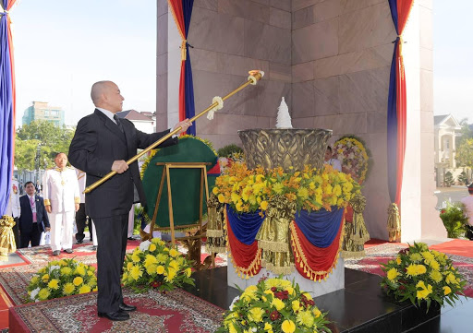

Witness the celebrations of this one of the major festivals of Cambodia.

Every year, Independence Day is a very special and happy day for the whole nation. It portrayed the Khmer success over colonization. It is celebrated in many places around the country, and the absolutely crucial one takes place at Independence Monument (វិមានឯករាជ្យ) in Phnom Penh.

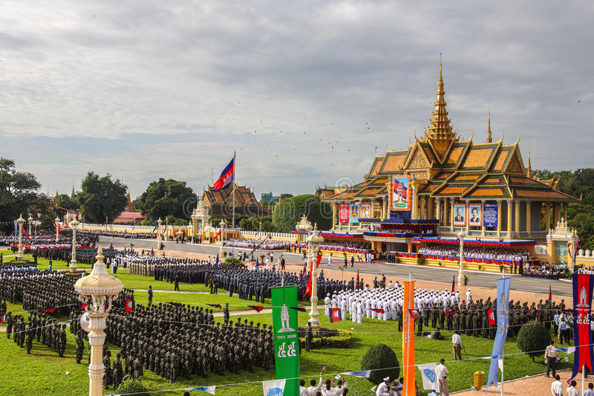

On that day, all the leaders and representatives of state organizations and public departments must participate and celebrate the formal ceremony in the morning. Usually the roads around the Independence Monument are closed to provide the space for the ceremony. The whole ceremony is broadcast on national television and radio. Other channels also broadcast it from the National TV. Therefore, the people around the country can watch it.

Every state palace is decorated with some slogans related to the independence of Cambodia, and the lights. At night, there is firework in the Chatomuk River (ទន្លេចតុមុខ) located in front of the Royal Palace. Because it is the holiday, there are a lot of people going out to see that event in front of the Royal Palace and Chroy Changvar area, which is opposite to the Royal Palace.

**When:**9th November 2020